HOMEWORK 6: My First Python Program

Write your first small Python program of your choice. This could be any short (preferably less than 50 lines of code) and simple program that you would like to code as your first Python program. (Note: you may choose one of our in-class examples and do a small change of your choice in code)
- Define what your program will do including the input and the output of your program.
- Write the high level algorithm of your program (step by step tasks/instructions that your program will follow in text)
- Code your Python program and test
- Run your code with a sample input and take screen shots of the output.
- Submit your Python program definition, your algorithm, the Python code and screen shots of your running code execution including test inputs and outputs.

Create a python script:
- That will ask me to enter up to 10 names
- Then will ask me if each of the persons named were naughty or nice
- Then ask me to list a gift for each name
  - The input for gifts is stored in a dictionary.
- At the end, the script prints a summary of each person's status and the gift they will receive.
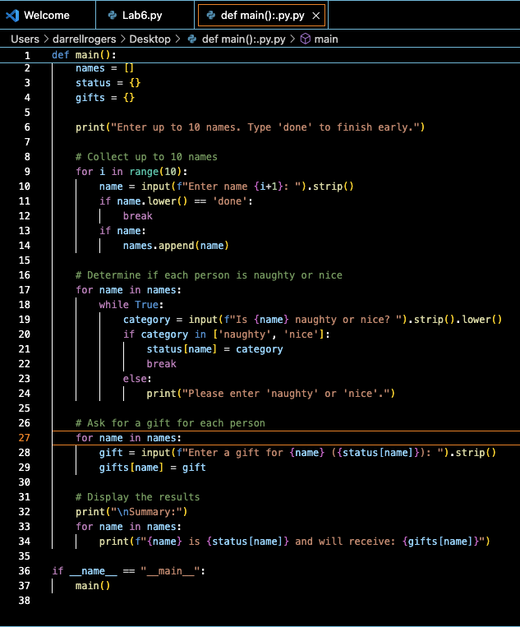
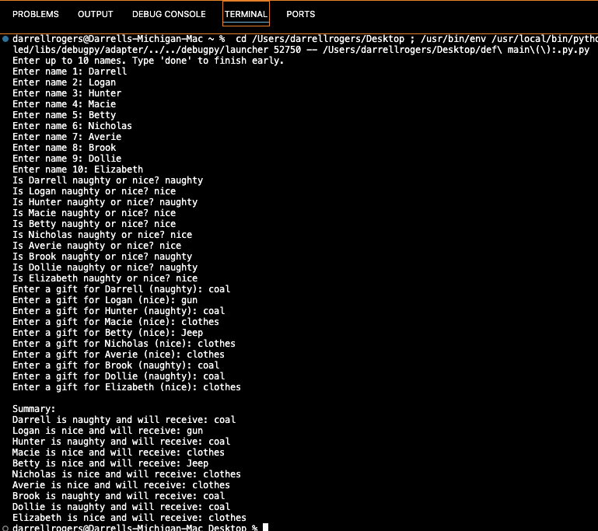
-----END-----

